Subject: |  | Date:
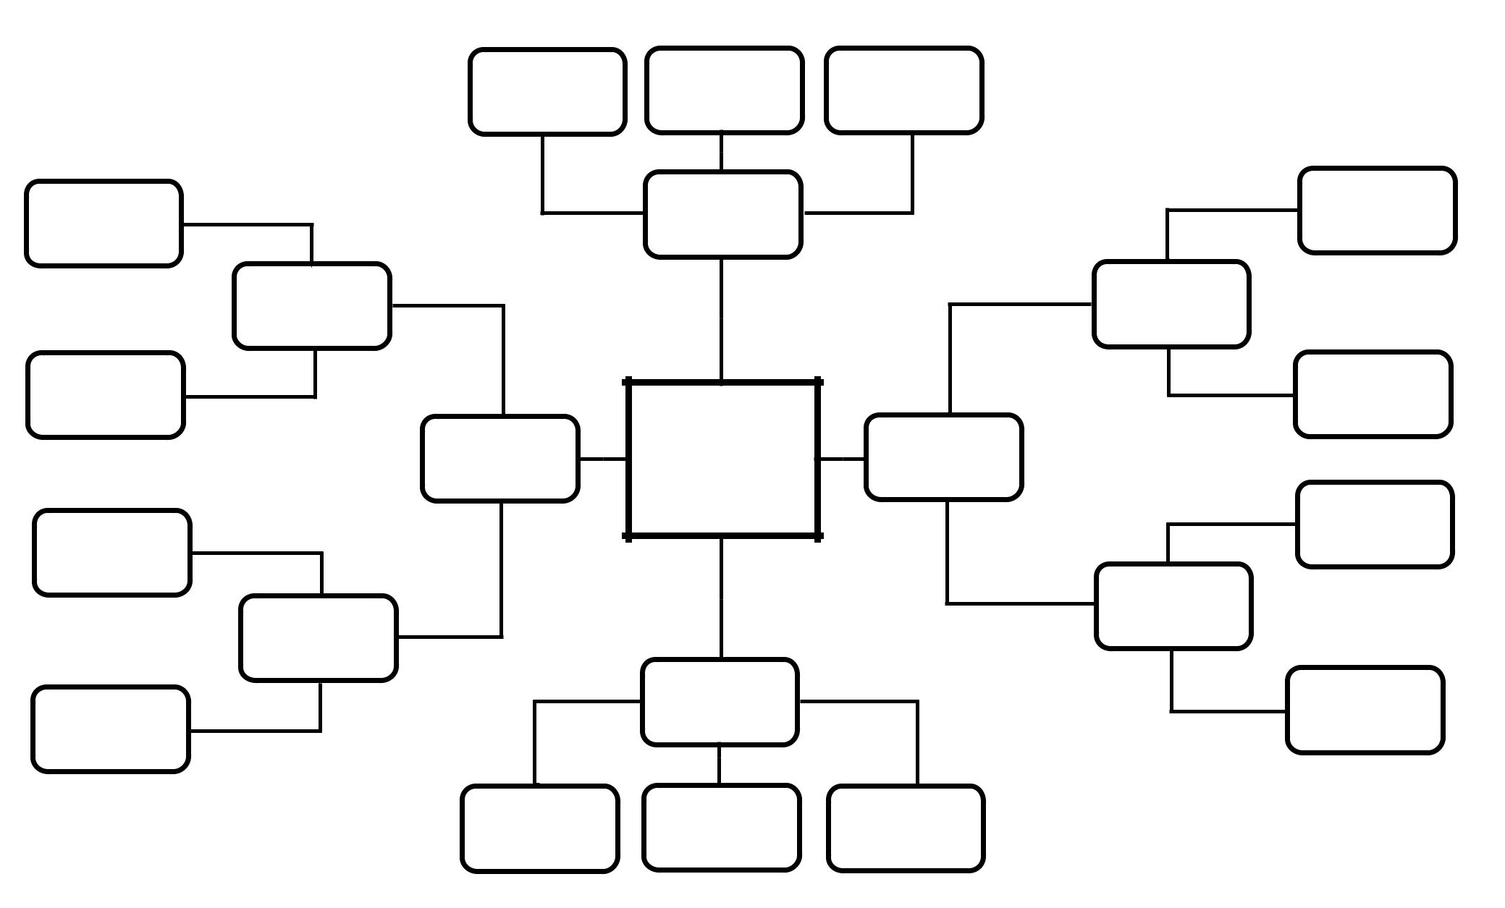

Check status.net for your brainstorming sessions and topical conversations!

Features:

1) Instant chat-style discussions with no page reloading.

2) Every idea has its own section for conversations to spark topical discussions.

3) Built-in emoji support to make the process more creative and fun.

4) Available 24/7: encourage creativity and let the ideas flow at any time, day or night.

5) Every brainstorming session has its own feed that is stored separately. Easily find it with built-in search features and go back to it in the future if needed.

6) Ideas can be filtered by topic, contributors, and/or date.

7) Ideas can be converted to PDF and printed - with or without additional discussions.

Click here to try it now for free.

