Meeting Agenda Template

MEETING AGENDA
Date: | Insert date here
Time: | Insert meeting time here
Location: | Insert meeting location here

Topic: |  |  |  |  | Attendees: | Insert attendees or group name
 |  |  |  |  | Facilitator: | Insert facilitator's name
Insert Meeting Topic Here |  |  |  |  | Recorder: | Insert note taker's name
 |  |  |  |  | Timekeeper: | Insert timekeeper's name
 |  |  |  |  | Other Role(s): | Use if there are other roles
Meeting Objectives:
• Insert meeting objectives, one per bullet point
To prepare for this meeting, please:

• Insert preparation instructions, one task per bullet point
Materials we will use at the meeting:

• Insert names of documents & other resources to be used in meeting, one per bullet point
Schedule [insert total number of minutes]
Time | Minutes |  |  | Activity
X:XX-X:XX | X |  |  | Welcome: Review meeting objectives and agenda
X:XX-X:XX | X |  |  | Recap: Review activities and feedback from last meeting (if applicable)
X:XX-X:XX | X |  |  | Topic name (protocol name, if applicable)
X:XX-X:XX | X |  |  | Topic name (protocol name, if applicable)
X:XX-X:XX | X |  |  | Next Steps: Agree on what participants will do after this meeting
X:XX-X:XX | X |  |  | Plus/Delta Protocol: Assess what worked and what didn't in this meeting

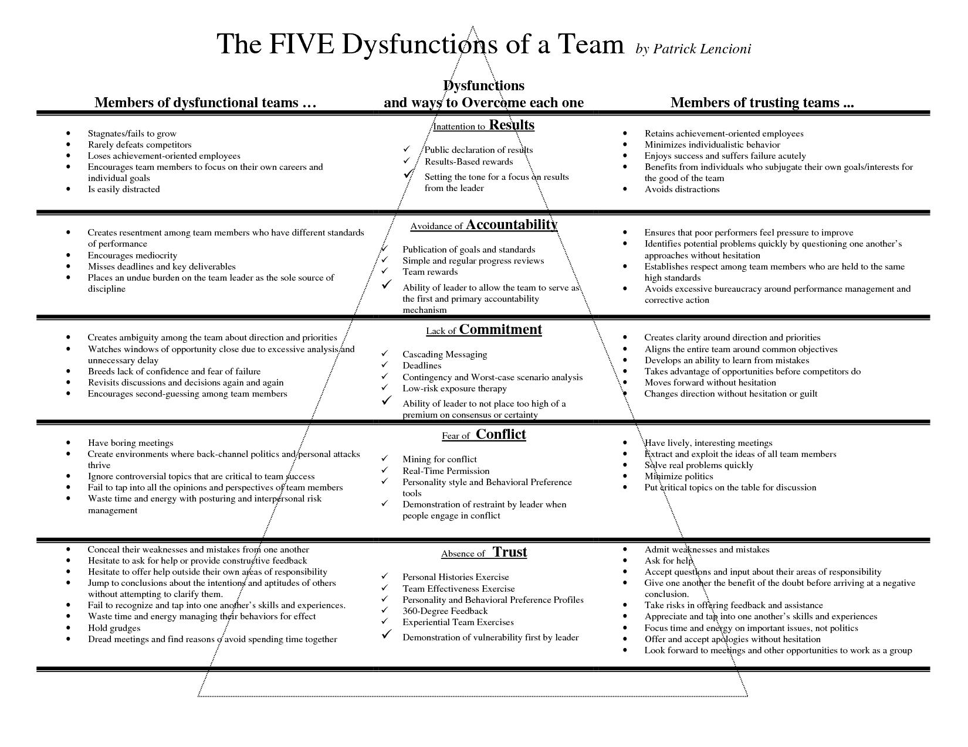

The Five Dysfunctions of a Team
By Patrick Lencioni

Instructions: Use the scale below to indicate how each statement applies to your team. It is important to evaluate the statements honestly and without over-thinking your answers.

3 = Usually
2 = Sometimes
1 = Rarely

_____ 1. Team members are passionate and unguarded in their discussion of issues.

_____ 4. Team members quickly and genuinely apologize to one another when they say or do something inappropriate or possibly damaging to the team.

_____ 6. Team members openly admit their weaknesses and mistakes.

_____ 7. Team meetings are compelling, and not boring.

_____ 10. During team meetings, the most important – and difficult – issues are put on the table to be resolved.

_____ 12. Team members know about one another’s personal lives and are comfortable discussing them.

Scoring
Combine your scores for the preceding statement as indicated below.

Dysfunction 1: Absence of Trust | Dysfunction 2: Fear of Conflict
Statement 4: ________ | Statement 1: ______
Statement 6: ________ | Statement 7: ______
Statement 12: _______ | Statement 10: _____
Total: _______ | Total: _______

A score of 8 or 9 is a probable indication that the dysfunction is not a problem for your team.
A score of 6 or 7 indicates that the dysfunction could be a problem.

A score of 3 to 5 is probably an indication that the dysfunction needs to be addressed.

Regardless of your scores, it is important to keep in mind that every team needs constant work, because without it, even the best ones deviate toward dysfunction.

Resource | Possible Uses | Possible Obstacles | Possible Modifications

Next Steps:

Tired of working with meeting agendas and meeting minutes manually? Status.net is a modern solution to share regular updates and gather insights automatically.

Status.net allows your team to share meeting summaries, discuss agendas, and send mass notifications, all with scheduled auto reminders.

Click here to try it now for free.

